PROCHILD PASSPORT

Monitoring & Resolving Violence, Exploitation and Abuse of Children within the SDG framework

Abstract

Transformation comes hand-in-glove with change, something that systems are not very keen to adapt themselves to. However, managing change and therefore, transformation becomes easier with the help of data led decision making. For nonprofits engaged in grassroots interventions, it is critical to have an ear to the ground with accurate data to ensure that the impact of their work is not only visible, but also measurable. However, sometimes it becomes difficult to assess the measurement metrics, especially for some of the intangible work that nonprofits engage in. Often, the data collected by nonprofits to measure their grassroots work is very heavily reliant on text which poses another challenge of mining usable information from the text to reach workable conclusions that have a direct impact on the lives of people. Most nonprofits work at an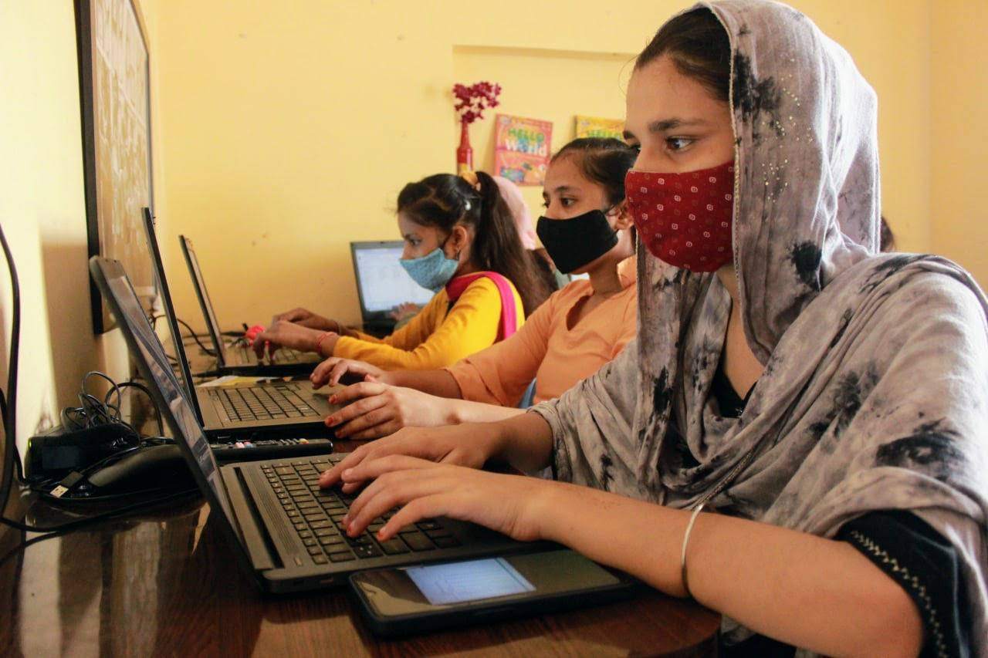 intersection of the sustainable development goals of education, livelihoods, poverty alleviation, hunger, health, gender equality, access to justice and others which makes their grassroots interventions complex in nature. Add to that strained geopolitical landscapes in the global South in Asia, Africa, and South America - home to more than 85 percent[1] of the world population - measuring impact becomes a complex, difficult, and critically necessary part of the equation.

At the intersection of all development work, one of the most critical pillars of development in communities around the globe remains education. In spite of the understanding that education can become the gateway leading out of integenerational poverty that has a direct impact on hunger, poverty, health, education, gender equality, better economic opportunities and more, it is still seen as an opportunity cost among the millions of inhabitants of the global south where the levels of education are often abysmally low in children at the last mile. For instance, in India, the ASER (Annual Status of Education Survey) samples and measures the overall situation of school enrollment and learning outcomes in children between the ages of 3-16 in the country. According to the last report published in 2021 after the devastating second wave of Covid-19 hit the country, the ability to read grade-1 text among children in grade-3 has dropped significantly from nearly 42 percent in 2018 to just above 24 percent in 2020.[2] The report is also significant because it showcases the need of interventions at the grassroots that are attuned to the evolving needs of children in the post-Covid-19 world where the number and nature of disruptions have been many. Among these disruptions, one that features prominently is access to technology and the role gender plays in access to technology for girls in underserved communities.[3] It has also been observed that such a divide in access to technology leads to a host of other issues for adolescent children, especially adolescent girls in migrant communities, who are not considered priority users for technology or candidates for quality education. This lack of access to technology and education leads to lack of access to understanding and exercising their rights and entitlements setting them back further in the development index. Furthermore, it has a direct impact on their financial and economic independence, and their ability to access justice and equality with the gap widening at every instance. In a world increasingly turning towards a digital led economy, those at the bottom of the pyramid are devoid of the opportunities available to them, in this case, inevitably girls from migrant families.

So what data do nonprofit organizations need to pivot in an evolving world to ensure that their grassroots interventions are suited to meet the needs of the communities they serve? How do they analyze and visualize it effectively to tell stories from the ground that have a direct impact on the program outcomes? This document aims to highlight one possible solution set that focuses on data collected at the grassroots at the intersection of access to education, technology, and linkages to the government infrastructure for last-mile communities by Protsahan India Foundation through art and technology focused interventions based on the HEART model (Healing, Education, Art, Recovery from trauma, and Technology). The model and interventions based on it are aimed at serving the grassroots communities at the last mile, primarily consisting of migrant families with a focus on adolescent girls. In these communities, one of the biggest challenges is sexual violence against children (SVAC) that remains unreported and unaddressed due to many factors, with social stigma being chief among them. Protsahan’s art and technology based interventions are designed to encourage girls to find their agency and stand up for themselves against abusive and detrimental situations in their lives. We will see through use cases and case studies from the ground on how data from the grassroots plays a vital role in shaping the course of the interventions at the grassroots, and how the inputs and grassroots wisdom is applied to ensure enabling support, not charity is at the center of the work in the communities. We will also see how data from the grassroots has enabled Protsahan to effectively grow its impact footprint in the communities and reach more than 81,000 girls annually through its programs.

Data Driven Decision Making At The Grassroots

Before we delve deeper into the need for data driven decision making at the grassroots, let us first understand why we needed data to begin with. It starts at the beginning of the community interventions to address instances of sexual violence against children in the slum communities of New Delhi. While trying to find its feet within the community, the small but dedicated team at Protsahan realized that deep connections with the community were necessary to reach out to the most vulnerable members of the community, and provide them immediate assistance in any form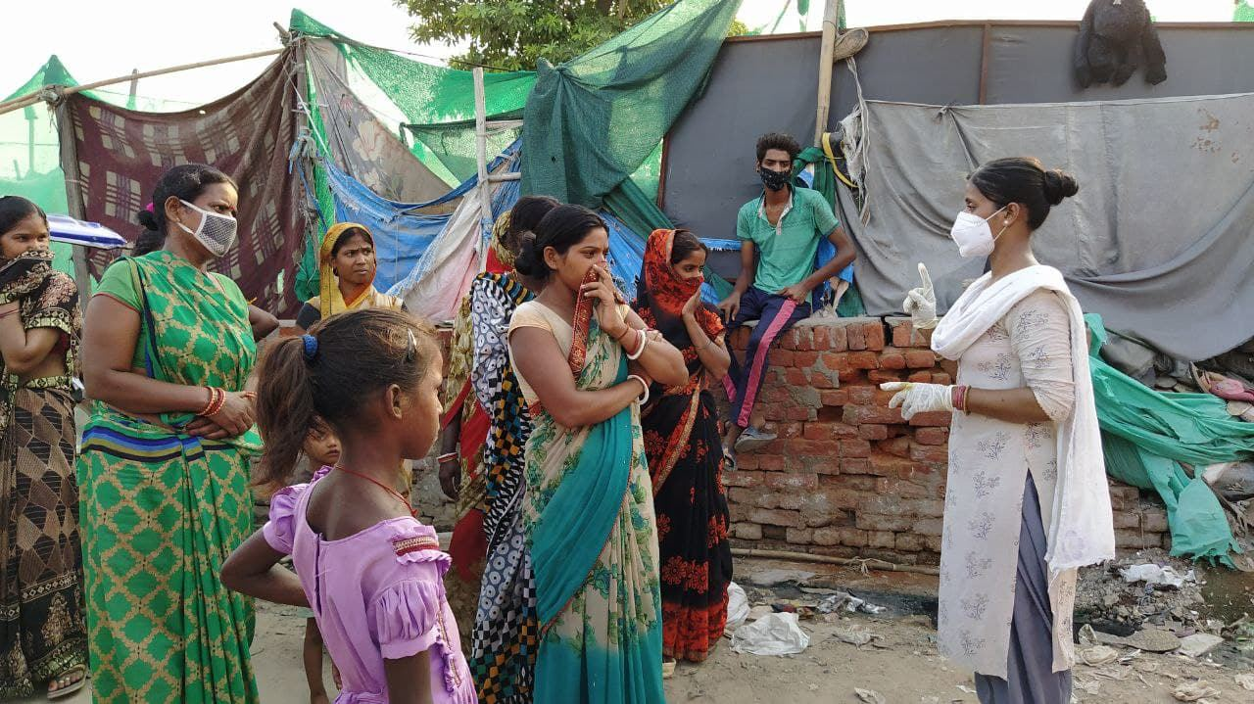 possible. However, that scenario did not play out very well for the organization as the quantum and quality of support provided by the team was not able to address some of the most basic needs of the community that resulted in a disconnect between the results and outcomes envisioned. Data in the form of human stories was needed from the ground to fine tune the response at the grassroots. It was also needed to ensure a deeper connection and understanding with the community members so that they would be ready to participate in any solution that was designed with them through a collaborative process. The learnings from the first instance of designing interventions for the community helped identify the need for data, and the pitfalls of failing to plan. We realized that first and foremost, data was needed to map vulnerabilities of migrant girls at the last mile in need of immediate support to stop instances of sexual violence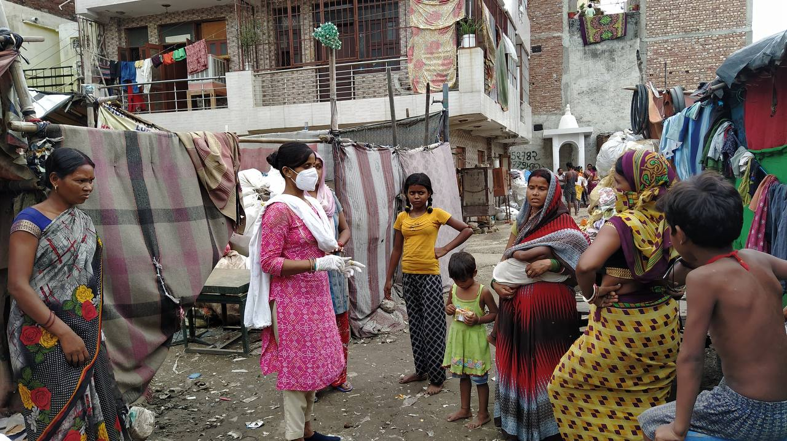 against them.

First step in the process is to assess the vulnerability of the child on a scale of 10, where the child is asked questions related to access to government services, access to school, etc. with the added vulnerability of being involved in begging, child labor, child transactional sex (unorganized sex work in lieu of rations for family), and with a family income of less than ₹ 5,000 per month (less than $ 62 per month). For a score of less than 2 (in case of no access to school, child labor, etc. and no access to government services), the child and her family is provided assistance in linking with the government social support services. For a score of less than 3 (in cases of extreme poverty, begging, rag picking, child transactional sex, extreme food insecurity, malnutrition, family income less than ₹ 5,000 per month, and no access to government social support services), a scholarship is provided to the child along with enrollment to school and linkage with government social support services to ensure that the child is mainstreamed into the formal education system. In cases where the vulnerability score is higher than 3, the child is considered at a very high risk, and therefore, falls under the category of Child in Need of Care & Protection (CNCP) as defined by the Juvenile Justice (Care & Protection of Children) Act, 2015[4] of India. In such cases, apart from linkages to the government social support services, the child is also enrolled at Protsahan Community Support Centers working deep inside the underserved slum communities to ensure complete care of the child.

This data is collected by the social workers at Protsahan who work very closely with the community, and command their trust to ensure that the data collected is accurate. They also serve as the focal point of community inputs that help in improving the data collection system. For example, during the course of their interactions with the community members, it came to light that malnutrition, stunting, and wasting are a major concern for the children in the slums. It needed to be measured along with the education outcomes to ensure that one cause was not lost on another, because while the children are malnourished, they will not be able to focus on the lessons in the classroom. To address such cases, Protsahan ensures that the child and her family is linked to the government ration distribution system that provides free or highly subsidized dry rations for families living below the poverty line.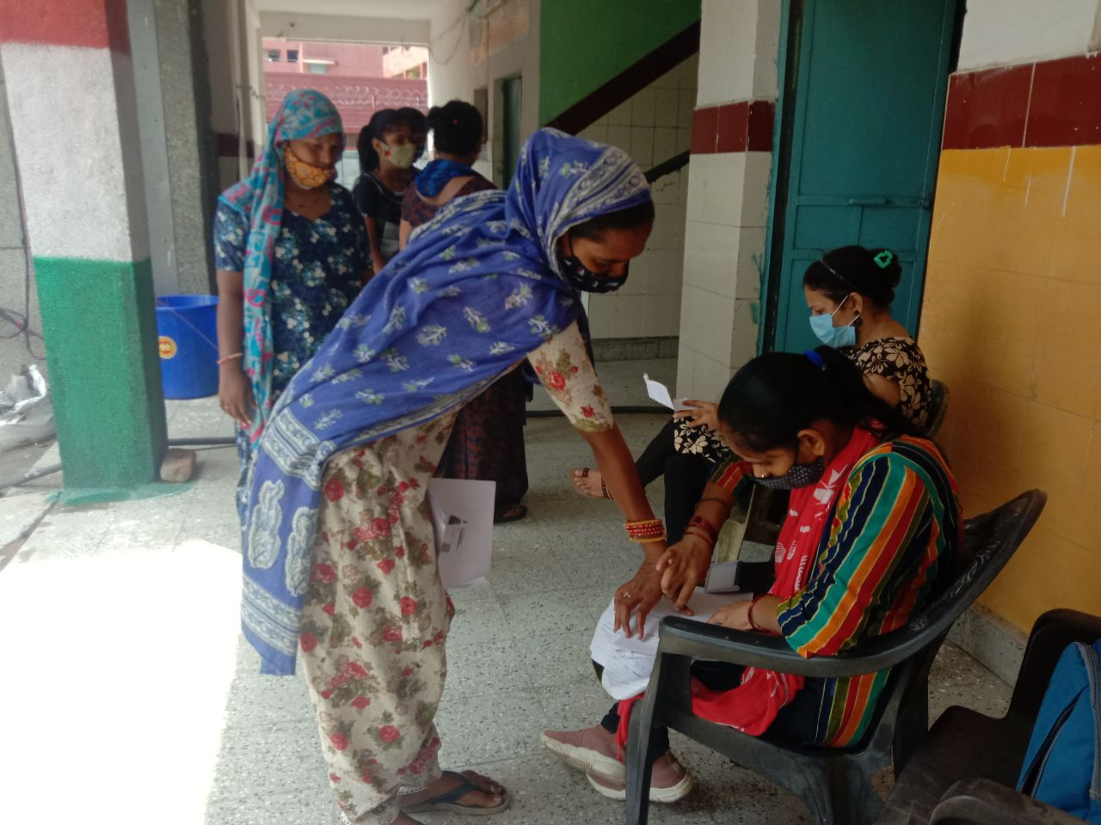

Such action at the grassroots level is not possible without effective data collection and analysis to ensure better decision making. However, this system of data collection and analysis is highly risk prone and has limitations. For instance, it is highly people dependent, leading to redundant and/or repeat data entering the upload stream if the training of data collectors is not thorough. Multiple team members reaching out to the community and/or change in the data collection team also leads to redundant/repeat data in the upload stream. It is also highly dependent on the knowledge of the beneficiaries, who often have no access & knowledge of government schemes and documentation, therefore, possess no understanding of their own documentation that they possess or need for future use. Being a very hierarchical society at every level, there are also trust issues that stem from cultural biases of the beneficiaries that results in unreliable data inputs from them. However, to mitigate this factor, Protsahan employs a local team of Youth Peer Leaders from within the community for frontline data collection tasks. Another very prominent limitation is the language barrier that hampers understanding of the need for data collection at the community level. To mitigate this, multiple choice questions based data collection questionnaires that are in simple colloquial language are used at the grassroots level.

However, the bigger challenge comes from unclear goal setting for the data collected. Unclear goal setting can hamper data quality, and leads to discrepancies in data analysis and solution implementation. Cloud storage space cost also limits the scope of implementation for a smaller organization working at the grassroots.

Looking closely at these challenges is critical because the data collected from the communities is intended for communicating directly with the communities through local “town hall” style councils, and sharing the analysis insights with them to help them arrive at local solutions for local problems. This “Design Thinking”[5] approach is essential for deeper, long-lasting impact that treats the communities as partners in their own growth, rather than discount them as recipients of charity alone. It is also critical to ensure that the grassroots interventions are aimed at bringing systemic changes rather than symptomatic changes in the underserved communities.

Case Studies

A cohort of Girl Champion Fellows and Youth Peer Leaders from within the community lead the collection of this data at the grassroots. This data is then vetted by the senior grassroots leaders to ensure data validity. This information then becomes essential in creating the bridges between available government infrastructure & services to solve hyperlocal issues with hyperlocal systemic solutions. The communities own and lead with this data for their good and it does not just stay with the organization. To this effect, the senior grassroots leaders ensure that they share the insights with the girls from the communities through dialogue where the community participates to hyperlocally address the issues highlighted by the data by bringing together intersections of - ICDS[6] (Integrated Child Development Scheme), State Govt., Police, NGO. We operate with participatory design, rooted in trust-building for democratization of data ownership and use for hyperlocal solutions.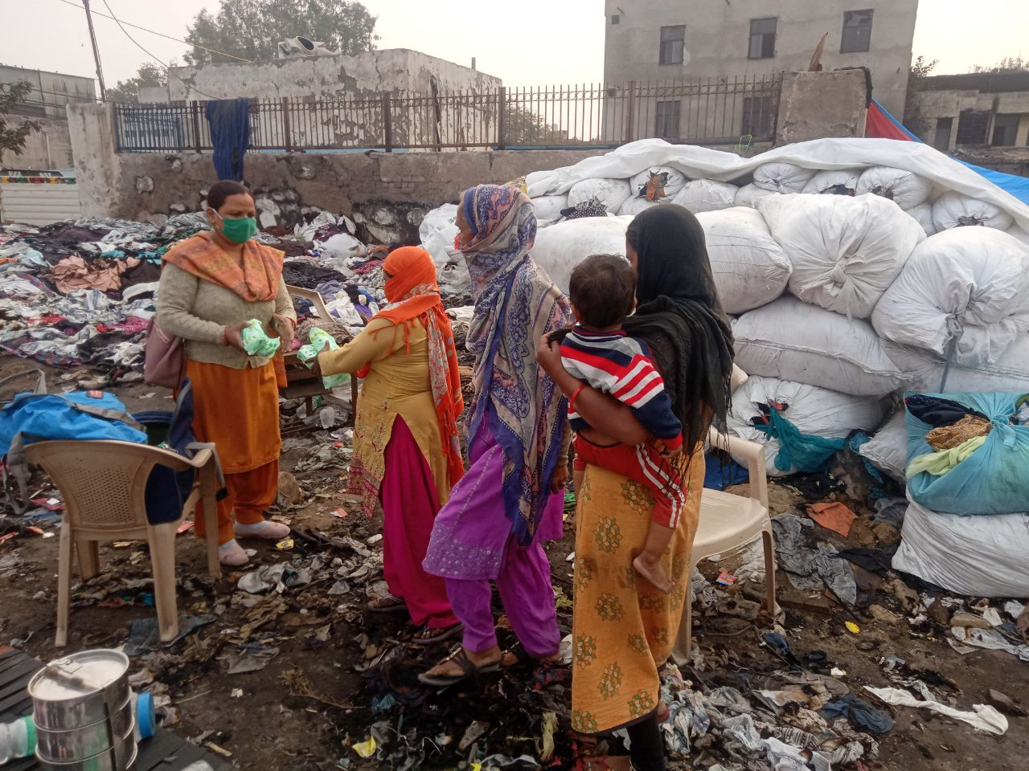

With the help of the data collected by the youth peer leaders from the girls directly, they identified many pressing needs at the grassroots for the community that have a deep impact on the lives of the girls.

#### Impact Point #1

Lack of street lights and overflowing drainage systems in the community was causing risk of spread of diseases in the community, and affecting the mobility of working women after dark. A higher rate of disease spread was directly affecting the capacity of daily wage workers in the community, and disproportionately impacting working women who were forced to forego wages to take care of sick members of the family. Dark alleys were becoming hotbeds for harassment and sexual violence against women as well.

The youth peer leaders recorded the specific locations within the community where the garbage and drainage systems were ineffective, and took these issues directly to the local legislator and civic authorities. Both issues were resolved within a week with the help of solid data points with respect to where the interventions were needed the most. The civic bodies were then able to address these needs in a timely and efficient manner, thereby having a direct impact on the lives of the adolescent girls and women in the community.

#### Impact Point #2

An immediate trend of rise in cases of incest, transactional sex, and begging was observed during the second wave of Covid-19 induced lockdowns. Data collected through conversations with the women in the community by the grassroots social workers and youth peer leaders helped in preparing a flagship report on the matter that was shared with the Delhi Commission for Protection of Child Rights (DCPCR)[7]. Local police and administration were alerted by the commission. Additional trainings for ICDS and Childline[8] teams were commissioned to build their capacity to address the situation, and prevent cases of violence against children.

#### Impact Point #3

Young girls from 15 schools reported shortage of free sanitary pads in their respective government schools after 500-days of school closures due to Covid-19 lockdowns. This issue was observed as a pattern across schools in Delhi as youth peer leaders from Protsahan and partner organizations across Delhi collected data from government run schools from around the city. A report was prepared by the girls from the data collected, and was presented to the Delhi Commission for Protection of Child Rights, who swung into action to resolve the issue for more than 425 Delhi schools at once as policy makers were alerted by the girls themselves and follow up action was taken to close the loop.

Digital Application

The data collection system is designed to draw insights and information that is highly relevant for use at the grassroots to address gaps between the needs and services available to the communities with adolescent girls at the center of each intervention. A cohort of Girl Champion Fellows and Youth Peer Leaders from within the community lead the collection of this data at the grassroots. This data is then vetted by the senior grassroots leaders to ensure data validity. This information then becomes essential in creating the bridges between available government infrastructure & services to solve hyperlocal issues with hyperlocal systemic solutions. The communities own and lead with this data for their good and it does not just stay with the organization. To this effect, the senior grassroots leaders ensure that they share the insights with the girls from the communities through dialogue where the community participates to hyperlocally address the issues highlighted by the data by bringing together intersections of - ICDS, State Govt., Police, NGO. We operate with participatory design, rooted in trust-building for democratization of data ownership and use for hyperlocal solutions.

The design of the solution from the beginning is based on ensuring that the most vulnerable group in communities – adolescent girls in the age group of 10-19 – have access to data to design their own solutions for the issues they face on a daily basis.

Objectives Of Digital Application Intervention

* The primary objective of data application is to move the organizational decision making from Data Driven to Data Led interventions at the grassroots – visualization for quick representation & easy understanding of key data points that impact decision making at the grassroots
  + By 2030, secure the prohibition and elimination of the worst forms of child labour for migrant children in Delhi and enroll them in govt. schools
  + By 2030, provide legal identity for poorest of poor migrant children in Delhi, including Aadhar registration for ease of access & linkages to unlocking benefits of govt. schemes
  + By 2030, secure the prohibition and elimination of child marriage for migrant children in Delhi and enroll them in govt. schools
  + Big focus on solving for gendered vulnerabilities of children in urban slums
* Create a structured M&E and beneficiary database for stakeholders to see tangible impact via dashboards
* Catalyze systems change by studying hyperlocal trends through
  + Enabling direct community work
  + Media advocacy

Data Points

Following data points were identified by the grassroots team in the first iteration of the application. These are being reviewed, and changes will be made as per the inputs from the team on the ground and evolving scenario at the grassroots level.

|  |  |  |  |
| --- | --- | --- | --- |
| Beneficiary Data Fields | | | |
| Field | Type | Value | Remarks |
| Child Details |  |  |  |
| First Name | Text |  |  |
| Last Name | Text |  |  |
| Sex | Drop down | M  F |  |
| DOB | Enter date |  | If possible, please write the full form - Date of Birth  With digit & field restrictions - while entering date of birth, entries should be in DD/MM/YYYY format. If the date is not entered in this format, system does not allow to move forward. |
| Age | Number (restricted to 2 digits) |  | Auto populated |
| Phone Number | Number restricted to 10 digits (with a prompt for less than 10 digits) |  |  |
| Address | Text |  |  |
| City | Text |  |  |
| State | Text |  |  |
| PIN Code | Number (restricted to 6 digits) |  |  |
| Type of Accommodation | Drop down | Owned house  Rented house  Hutment |  |
| Image | Image selection OR photo by phone camera |  |  |
|  |  |  |  |
| Child Services Details |  |  |  |
| Aadhar (Y/N) | Drop down | Yes  No |  |
| If yes, UID Number | Restricted to 12 digits |  |  |
| (UID Photo) |  |  |  |
| Ration Card (Y/N) | Drop down | Yes  No |  |
| If yes, Ration Card Number | Text box |  |  |
| (Ration card photo) |  |  |  |
| School (Y/N) | Drop down | Yes  No |  |
| If yes, school name | Text box |  |  |
| Linked to Govt. Services by Protsahan (Y/N) | Drop down | Yes  No |  |
| If yes, service name | Check box list | Aanganwadi  School admission  Aadhaar/PAN  Ration card  Any other |  |
| Enrolled with Protsahan (Y/N) | Drop down | Yes  No |  |
| If yes, center name/number | Drop down | GEC 01  GEC 02  GEC 03  GEC 04  GEC 05 | Only activated if the answer to the previous question is "Yes" |
| Date of joining Protsahan | Enter date |  | With digit & field restrictions - while entering date of birth, entries should be in DD/MM/YYYY format. If the date is not entered in this format, system does not allow to move forward. |
| Support received | Check boxes | Academic Support (Tuition)  Scholarship  Digital Access & Infrastructure  Life Skills (SRHR, Gender, Child Safety, Digital & Financial Literacy etc.)  Counseling & Psychosocial Support (Arts)  Linkage With Govt. Schemes  Age Appropriate Learning Kits  Need Based Wellbeing Kits  Protein Rich Nutrition Kits  Family Ration Kits  Fellowship  ~~Covid-19~~ Cash Relief  Aadhar Registration |  |
| Child rights violation | Check boxes | Physical Abuse  Emotional Abuse  Child Marriage  Child Sexual Abuse  Child Labour  Begging  Homelessness  Neglect  Death of Parent(s)  Loss of Guardian’s Employment |  |
|  |  |  |  |
| Child Family Details |  |  |  |
| Father’s First Name | Text |  |  |
| Father’s Last Name | Text |  | Last name picked from above where we wrote child’s last name |
| Occupation of Father | Drop down | Begging  Rag Picking  Daily Wage Worker  Vegetable Seller  Rented Rickshaw Driver  Domestic Helper  Unemployed |  |
| Mother’s First Name | Text |  |  |
| Mother’s Last Name | Text |  | Last name picked from above where we wrote child’s last name |
| Occupation of Mother | Drop down | Begging  Rag Picking  Daily Wage Worker  Vegetable Seller  Rented Rickshaw Driver  Domestic Helper  Unemployed |  |
| Siblings | Drop down | 1-10+ |  |
| Person(s) with disability in family | Drop down | Yes  No |  |
| Native Place (State) | Drop down | States & UT names |  |
| Monthly household income | Drop down | Up to ₹ 5,000  ₹ 5,001 - ₹ 10,000  ₹ 10,001 - ₹ 20,000  Above ₹ 20,000 |  |
|  |  |  |  |
| Nature of Child |  |  |  |
| Nature | Check box list | Shy  Quiet  Talkative  Aloof  Friendly  Angry  Aggressive |  |
| Behavior | Drop down | Introvert  Extrovert  Ambivert |  |
| Hobbies & Special Interest | Text box | Art  Dancing  Music  Yoga  Karate  Ludo, chess, carrom  Photography  Any Other | No more than 10 words |
| Likes School | Drop down | Yes  No |  |
| Favorite Subject | Drop down | Hindi  English  Mathematics  Social Studies  Science |  |
| Arts | Drop down | Drawing & Painting  Theater  Music  Mandala Art  Madhubani  Warli  Dance  Origami  Cooking |  |
| Sports | Drop down | Volleyball  Football  Cricket  Hockey  Running  Track & field  Kabaddi  Others |  |
| Aspiration | Text box | When I grow up I want to be… | No more than 10 words |
| Baseline Score | Number (restricted to 3 digits for score of max. 100) |  |  |
| Endline Score | Number (restricted to 3 digits for score of max. 100) |  |  |
|  |  |  |  |
| Interaction Details |  |  |  |
| Date of interaction | Date (auto populated by system date) | DD/MM/YYYY format | (this will need to be recorded each time, from the first time till the engagement with the beneficiary continues, small notes need to be added to each date by the staff member interacting with the beneficiary) |
| Narrative (limited to 250 words or something, we’ll decide on the word limit later. Also, could it be automated somehow, or transcribed from a voice note of under 90sec. Need to ideate/suggestion invited) |  | Auto generated | Permutations of:  Personal details - Himanshi's parents are Supriya and Madhav. She has 2 younger siblings. The family is settled in Delhi. Himanshi is very shy in nature and introverted. But she talks freely with everyone once she gets to know them closely and begins to trust them. She loves drawing and painting. She is also good at Volleyball. She wants to be a pilot when he grows up. |

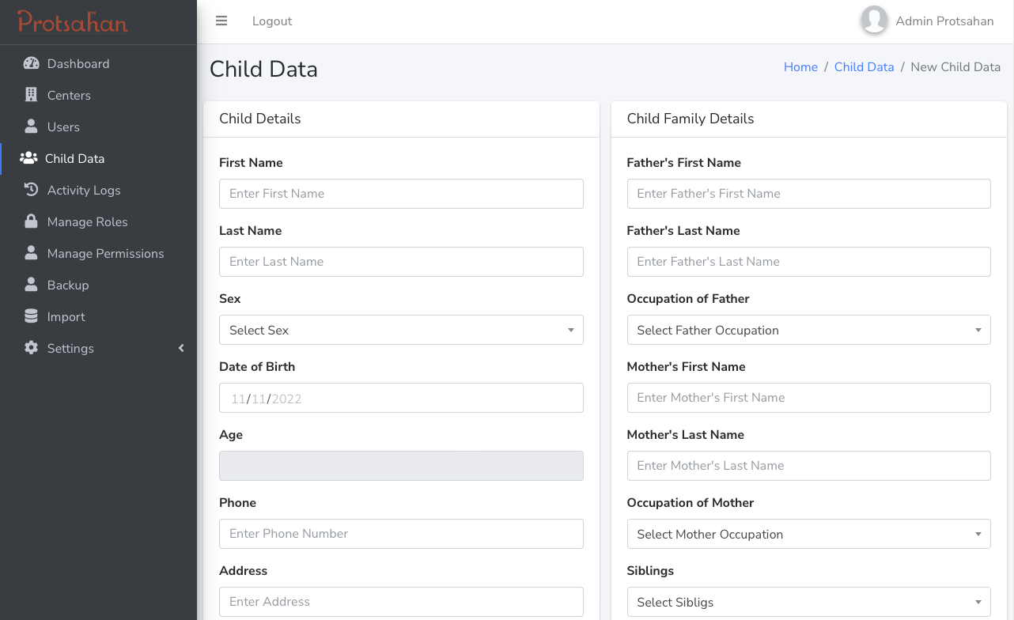

Application Framework

The application framework is designed to enable communities by giving them control over their data.

#### Data Flow

Conversations to build trust with community members >> data collection & storage by adolescent girls >> data validation by senior grassroots leaders >> analysis >> insights in the form of charts indicating trends >> conversations with girls and community to build solution sets >> linkages to local govt. department >> implementation of solution sets

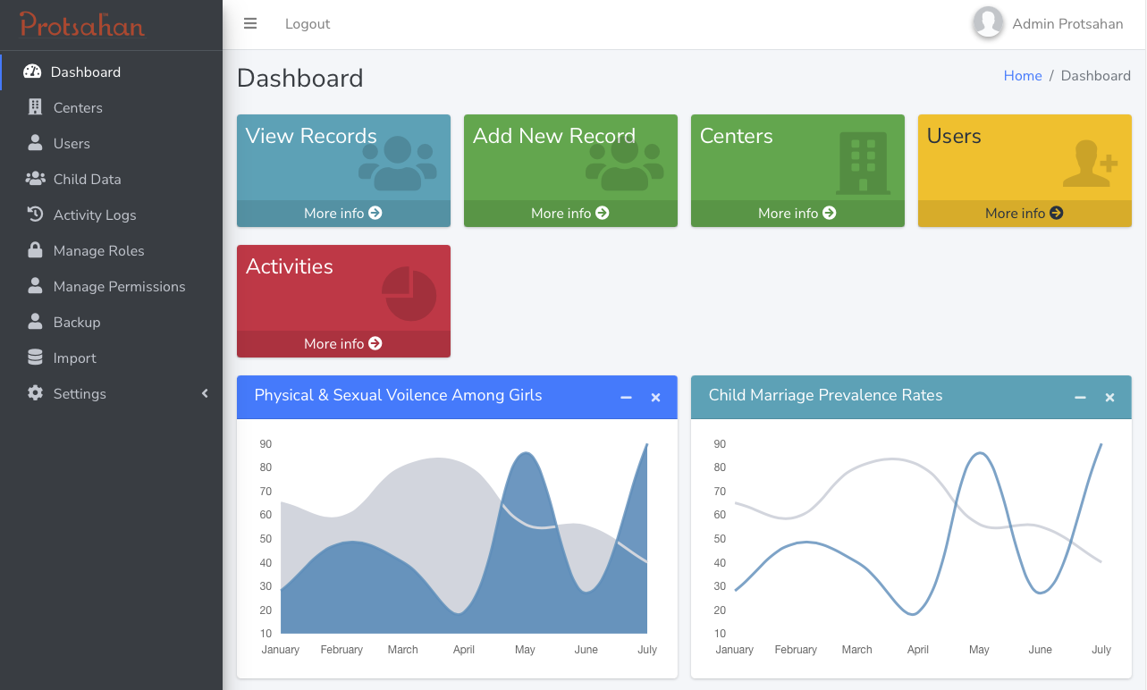

The data collected by the team of youth peer leaders is checked for discrepancies and cleaned by the supervisory team of senior grassroots leaders before being analyzed manually by the upper leadership team for trends. This analysis is currently manual due to limited understanding of automated/machine analysis systems before visualization and sharing with relevant stakeholders to effect hyperlocal systems change through media and government advocacy.

Data Collection Process (Data Integrity & Cleaning)

To ensure that data collection process maintains a high level of integrity at every stage, it is imperative that

* Training of Child Protection Officers (CPOs) & Youth Peer Leaders (YPLs) is thorough, and in line with the legal framework of the country with respect to data privacy
* Community outreach through social workers and youth peer leaders embedded in the communities, and grassroots wisdom acquired over the last decade are put in application for data collection to ensure participation of the community leaders
* Maintaining siloed roles and responsibilities for oversight to ensure that the process of collection, cleaning, storage, retrieval, and application of data does not compromise the safety of the children

Data Storage & Privacy

At present, all data is stored in encrypted private cloud servers to ensure safety and privacy of the data, especially since it concerns children in need of care and protection by definition of law. This storage space is augmentable to ensure future needs, and easily accessible to appropriate user levels defined in the system.

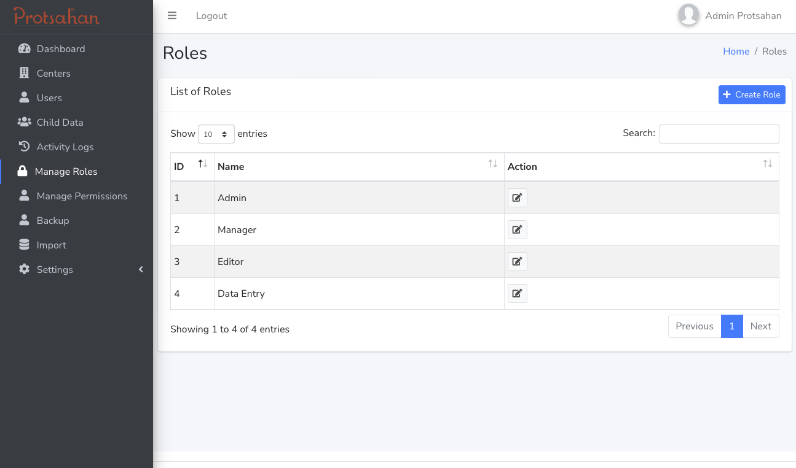

Data Retrieval, Analysis, & Visualization

Easy access to data is essential for the grassroots team to reach valid conclusions that have a direct impact on the community, and ensure that the community owns the data and insights thus derived.

* Non technical method of retrieval for ground team
* Immediate & time sensitive

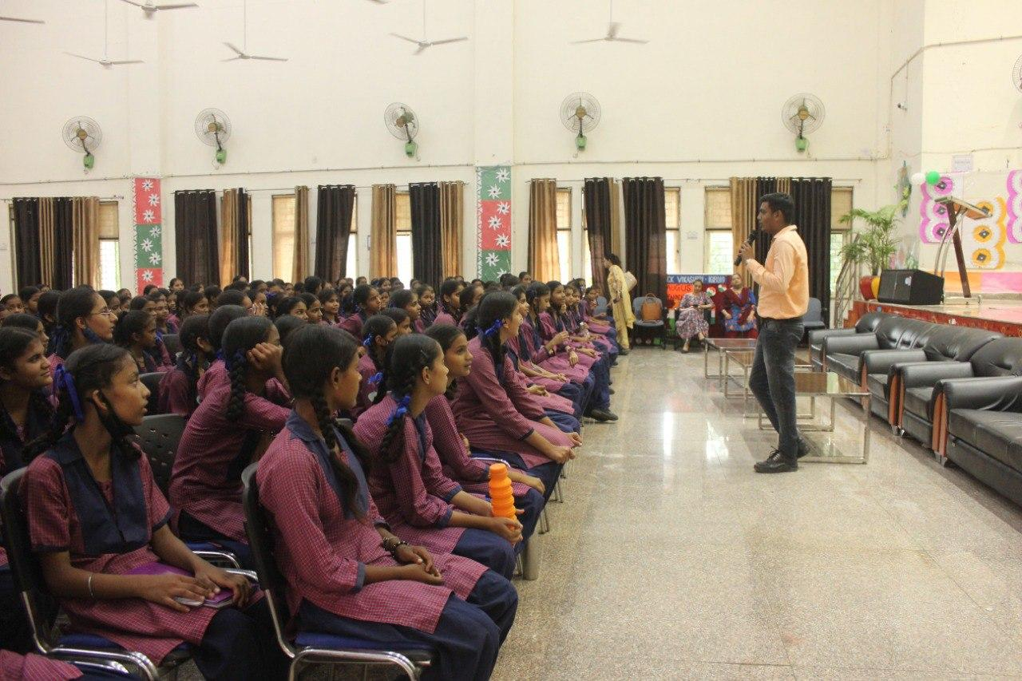Analysis with the defined outcomes and purpose in mind,

* must not be done with a confirmation bias
* should not be resource intensive leading to death by data

Visualization for quick representation & easy understanding of key data points that impact decision making at the grassroots,

* for internal decision making at the grassroots level to course correct programs and interventions if needed
* for donors to see tangible impact via dashboards
* for policy & research purpose
* for media advocacy for systems change

Data Driven Sustainability

To achieve the near-mythical “sustainability” of the system as often envisioned by the nonprofit sector, the application has to be an effective tool for monitoring and evaluation at the grassroots level. It has to be capable of producing visual information from the data that can be applied in real world scenarios at the grassroots for effective utilization of the stakeholders and resources to ultimately impact the last mile communities. As we have seen over the years at Protsahan that anecdotal evidence from the grassroots plays a critical role in modeling the interventions and the impact thereof. Therefore, it is imperative that the application be designed with the objective of enabling and empowering the communities directly involved.

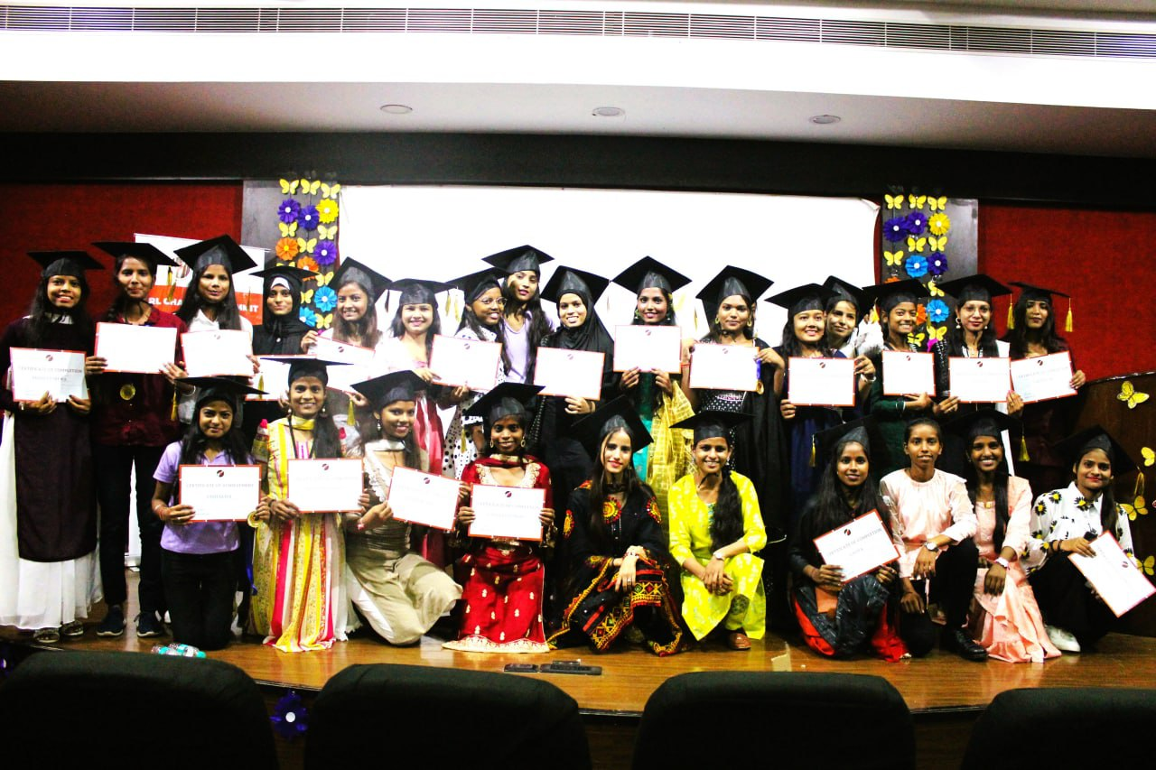

It also must be agile enough to accommodate future needs, and adapt accordingly. Modularized implementation of the application can achieve that when done with the needs of the community in mind along with cost structure to support implementation, updates released in a time bound manner, flexible cloud storage, and robust analysis and visualization to create systemic change that renders a positive impact on the lives of migrant girls.

1. Source : <https://www.prb.org/>
2. ASER 2021 : [Survey Report](http://img.asercentre.org/docs/aser2021forweb.pdf)
3. India’s Gendered Digital Divide : [Survey Report](https://protsahan.co.in/wp-content/uploads/2020/07/Indias-Gendered-Digital-Divide_Protsahan-Survey.pdf)
4. Source: [Legislative Department, Government of India](https://legislative.gov.in/actsofparliamentfromtheyear/juvenile-justice-care-and-protection-children-act-2015)
5. Source: [Ideo.org](https://designthinking.ideo.com)
6. Source: [Department of Social Welfare, Ministry of Women & Child Development, Government of India](https://icds-wcd.nic.in)
7. Source: [DCPCR](https://dcpcr.delhi.gov.in)
8. Source: [Childline India Foundation](https://www.childlineindia.org)